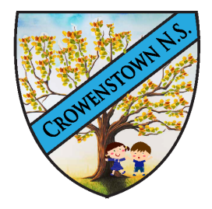
St. Patrick’s National School, Crowenstown,
Delvin,
Co. Westmeath. N91 X7DV

_______________________________________________________________ Phone: 044 9664585
Roll No: 02263S Email:office@crowenstownns.ie
Website: www.crowenstownns.ie
C.R.N.- 20204931
7/10/2026
Dear Parent/Guardian, Student and Community members,
Subject: Primary School Survey – Update

The B.O.M. has considered the outcome of the results and any feedback received and there will be no change in the configuration of St. Patrick’s N.S. Crowenstown.

Yours sincerely,
Fr. Heaney (Chairperson of the BoM)
Carmel Thorpe (Principal)

